Vector + Iterator

Iterator

vector <int>::iterator it;

for(it = v.begin();it != v.end();++it)

cout << *it << ‘ ‘;

***Declaring vector and input taking;***

#include <vector>

vector<int> v;

vector<int> a; // empty vector of ints

vector<int> b (5, 10); // five ints with value 10

vector<int> c (b.begin(),b.end()); // iterating through second

vector<int> d (c); // copy of c

vector< int > v[10]; //vector array

vector <char> v;

int p ; cin >> p;

v.push_back(p);

for (auto i = v.begin(); i != v.end(); ++i) cout << *i << " ";

for (auto ir = v.rbegin(); ir != v.rend(); ++ir) cout << *i << " ";

**Output:**

Output of begin and end: 1 2 3 4 5

Output of rbegin and rend: 5 4 3 2 1

Tricks ;

1.V.size()

**2.v.assign(5, 10);**

The vector elements are: 10 10 10 10 10

3.  Inserts 15 to the last position

**v.push_back(15);**

4. Removes last element

**v.pop_back();**

5. Inserts 5 at the beginning

**v.insert(v.begin(), 5);**

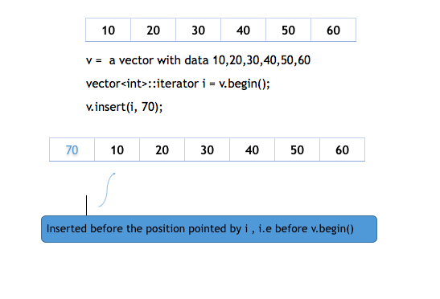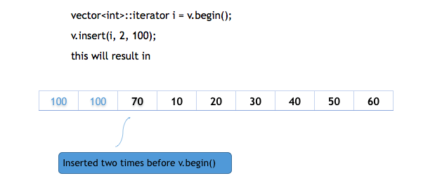

6. Removes the first element

**v.erase(v.begin());**

Removes all the elements except last two

**v.erase(v1.begin(), v1.end() - 2 )**

7. Two vector to perform swap

**vector<int> v1, v2;**

    v1.push_back(1);

    v1.push_back(2);

    v2.push_back(3);

    v2.push_back(4);

Swaps v1 and v2

**v1.swap(v2);**

Vector 1: 1 2

Vector 2: 3 4

After Swap

Vector 1: 3 4

Vector 2: 1 2

8.

vector<string> names;

names.push_back("brad");

names.resize(5, "mary"); **produces the output:**

names[3] = "tom"; brad

mary

for (int i = 0; i < names.size(); i++) mary

cout << names[i] << endl; tom

mary

**sort(v.begin() , v.end() );**

**reverse(v.begin() , v.end() );**

CPP program to create a 2D vector where :

int main()

{

// size of row

int row = 5;

int column[] = { 5, 3, 4, 2, 1 };

// Create a vector of vector with size

// equal to row.

vector<vector<int> > v(row);

for (int i = 0; i < row; i++)

{

// size of column

int col;

col = column[i];

// declare the i-th row to size of column

v[i] = vector<int>(col);

for (int j = 0; j < col; j++)

v[i][j] = j + 1;

}

/*

Input : Number of rows : 5

Number of columns in rows :

2 3 4 5 1

Output : 1 2

1 2 3

1 2 3 4

1 2 3 4 5

1

Input : Number of rows : 3

Number of columns in rows :

3 2 1

Input : 3 3 2 1

Output : 1 2 3

1 2

1

*/

***Vector Function :***

vector<int> stringtoint( string s )

{

vector<int>convertedint;

stringstream convert(s);

int number;

    char space;

    while(convert>>number)

    {

      convertedint.push_back(number);

convert>>space;

} return convertedint;

}

int main()

{

    string s;

    cin>>s;

    vector<int> arr = stringtoint(s);

    for(int i = 0 ; i<arr.size() ; i++)

    {

        cout<<arr[i]<<endl;

    }